Length: Six sources, each with MLA citation and min. six sentence annotation

Value: 100 points or 10% of final grade

Submission: Submit a Word doc., docx, or pdf to Canvas

Prompt
To assist with gathering and synthesizing your research for your ethical proposal for Project 3, you will complete an annotated bibliography formatted to MLA. Similar to a Works Cited page, you must identify your sources, and alphabetize them by author's last name or title if no author is provided. After each bibliographic citation, you will write a six-sentenced annotation. The content of these annotations is listed below.
Remember to title your document Annotated Bibliography and adhere to MLA formatting guidelines. An example of a citation and annotation are provided at the end of this prompt. Please note that annotations will not be required for Project 3, only this assignment.

Audience
Use your Project 3 audience.

Requirements
For each entry, you will either follow the following adaption from UC Irvine’s Annotation Guidelines:
- The correct MLA citation for the piece.
- A six-sentence annotation that includes the following:
  - A first sentence that indicates who the author or source is, and why his/her/its opinion matters. (ex: John Doe is a professor of history at Harvard University who studies the Holocaust)
  - A second sentence describes the intended audience or ideal reader for the text, including textual clues you notice about the kind of audience the author had in mind.
  - A third sentence that explains the source’s thesis in the form of a “signal verb” and “that” clause. (ex: Doe argues that….)
  - A fourth sentence that states the author’s evidence used to support and illustrate the thesis (ex: statistics from studies, survey results, personal experience and observation, various examples—including hypothetical and imaginary examples, anecdotes, scientific facts from research, logical reasoning, etc.)
  - A fifth sentence that states the author’s purpose (the effect he or she or it desires to create by arguing the thesis).
  - A sixth and final sentence evaluates the source, explaining whether or not it is effective at getting its intended point across and why.

Example
Below is an example of the six-sentence annotation with the proper MLA indent:
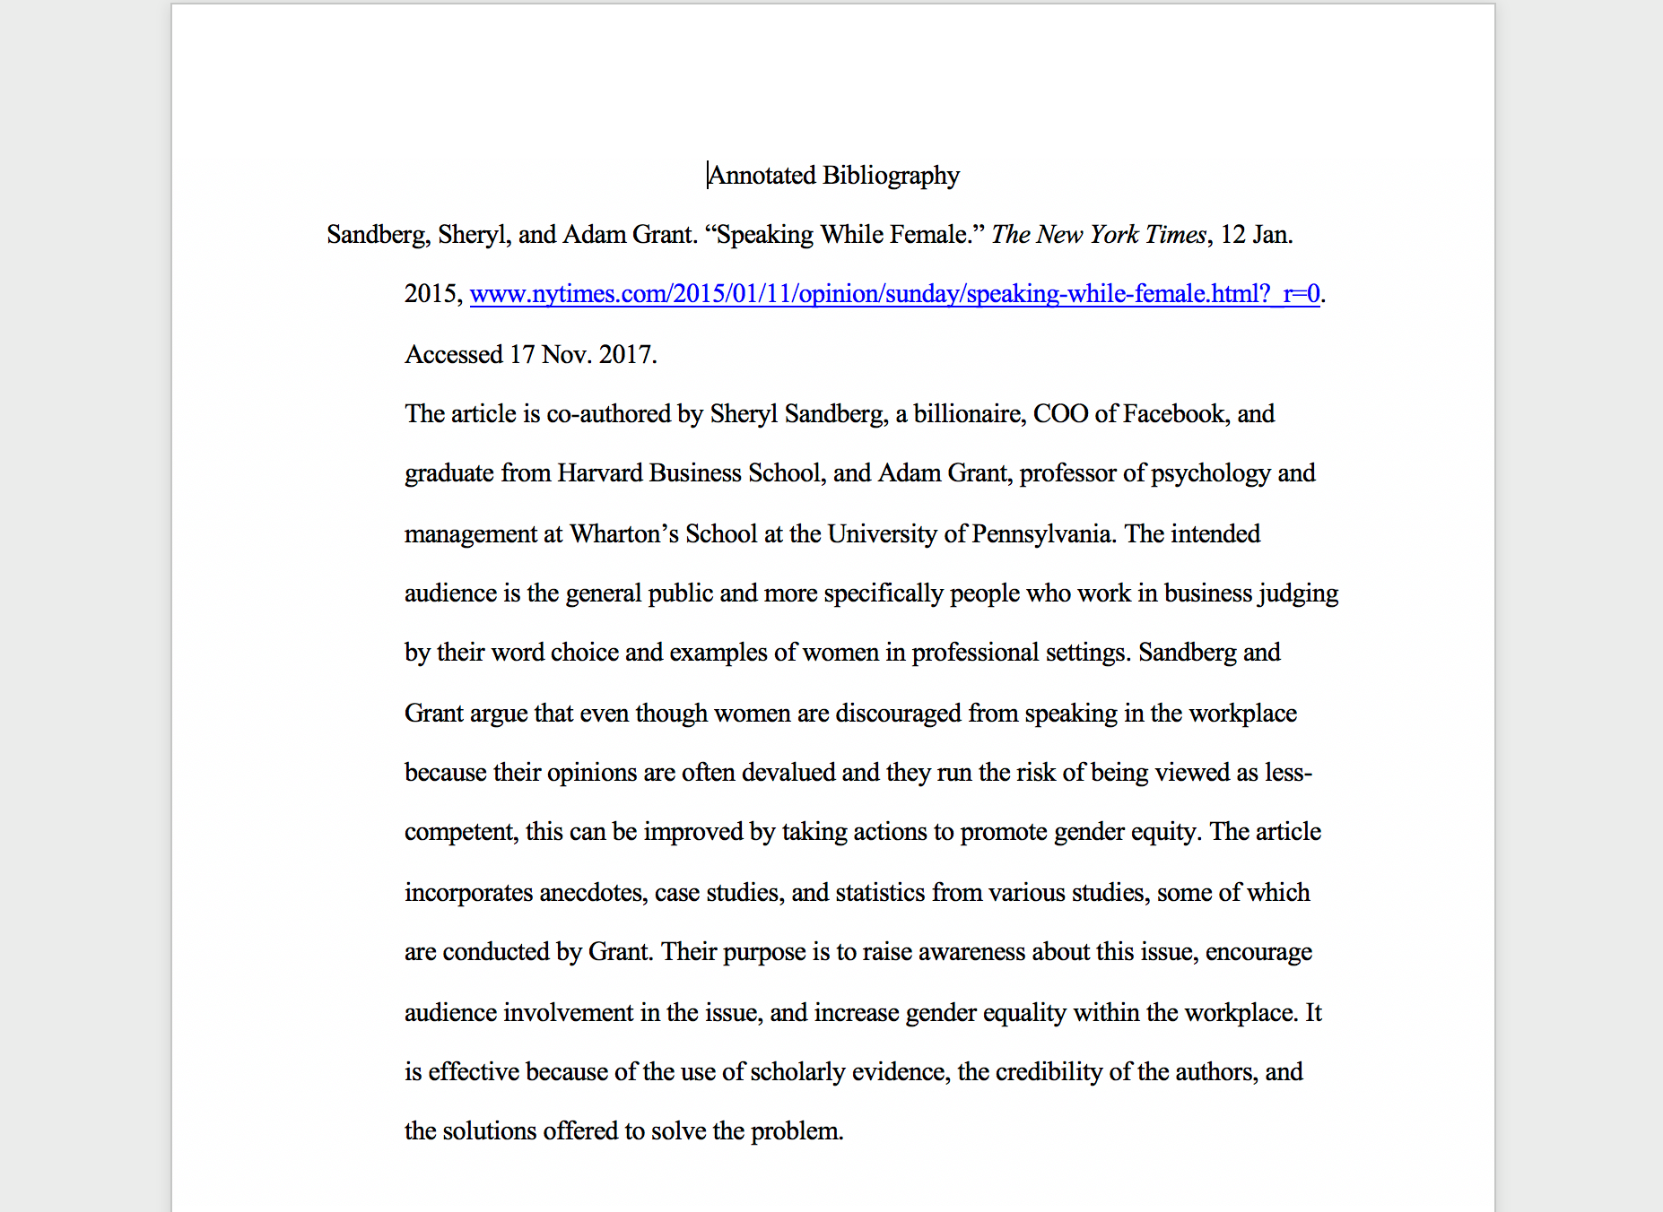
Text of image (above):

Annotated Bibliography

Sandberg, Sheryl, and Adam Grant. “Speaking While Female.” The New York Times, 12 Jan. 2015, www.nytimes.com/2015/01/11/opinion/sunday/speaking-while-female.html?_r=0

(Links to an external site.)

. Accessed 17 Nov. 2017.

The article is co-authored by Sheryl Sandberg, a billionaire, COO of Facebook, and graduate from Harvard Business School, and Adam Grant, professor of psychology and management at Wharton’s School at the University of Pennsylvania. The intended audience is the general public and more specifically people who work in business judging by their word choice and examples of women in professional settings. Sandberg and Grant argue that even though women are discouraged from speaking in the workplace because their opinions are often devalued and they run the risk of being viewed as less-competent, this can be improved by taking actions to promote gender equity. The article incorporates anecdotes, case studies, and statistics from various studies, some of which are conducted by Grant. Their purpose is to raise awareness about this issue, encourage audience involvement in the issue, and increase gender equality within the workplace. It is effective because of the use of scholarly evidence, the credibility of the authors, and the solutions offered to solve the problem.

